PROVENANCE: FRANK REAUGH,
VERSION OF “APPROACHING HERD/BREEZY MORNING”.
COMPLIED BY SAM PEMBERTON
OCTOBER 2020

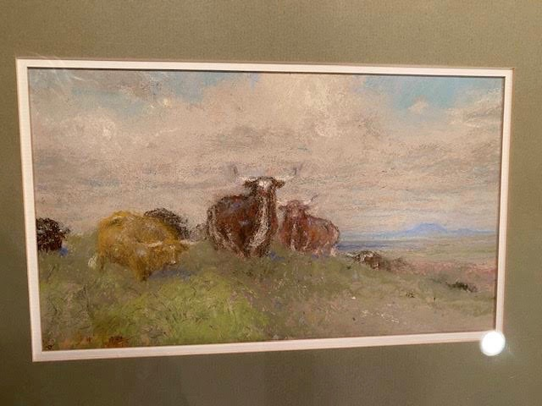

This Frank Reaugh pastel painting was purchased by Sam and Karen Pemberton on June 13, 2013. The painting is 5.5 X 8.5 inches and is larger than many Reaugh field studies. It is unknown when it was painted. This painting is a version of “Approaching Herd”/”Breezy Morning” as well as the large Frank Reaugh painting owned by the Summerlee Foundation in Dallas Texas.

All pages, copyright 2020: Sam Pemberton
It is the purpose of this paper to document the provenance and history of this painting for Texas Art collectors, future owners, or researchers. Collectors and dealers in Early Texas Art often amass significant information regarding provenance and history of their paintings. The vast majority of this information is never shared and is often lost when the collector or dealer dies or stops collecting. It is my opinion that the sort of information in this paper must be compiled and archived at a site like CASETA for the benefit of future owners and collectors of Early Texas paintings.

We purchased this pastel from Larry, Boettigheimer, Frontiers Texas Gallery, Arlington, Texas. I had been in contact with Larry for some time about any Frank Reaugh Pastels that he might have available. He called me out of the blue with this item.

Larry was in the process of dealing with Michael Grauer at the Panhandle-Plains Historical Museum to work out a trade on some materials he had on W. Herbert Dunton for some Frank Reaugh pastels.

On June 4, 2013, Larry notified me that he had finally concluded the trade with Micheal Grauer and the Panhandle Plains Museum of his William “Buck” Dunton (Taos Society of Artists) materials. Larry had previously sent me images of some Reaugh pastels that might form part of the trade. Those pastels were eventually rejected and Michael came up with much better material to make the deal happen.

Two of the pastels in the new materials were exceptional. The first was this version of “The Approaching Herd”/”Breezy Morning”. The other exceptional pastel that Larry received as part of the trade was a study for “Prophets Ford”, one of Reaugh’s signature paintings now held by the University of Texas. Prophets ford is two feet five inches by 5 feet and among Reaugh’s most important large scale paintings. The small study traded to Larry was 3.5 inches by 7.25 inches. Unfortunately we were not able to afford to purchase the small study for Prophets Ford, however, the information contained in this paper would also apply to that painting.

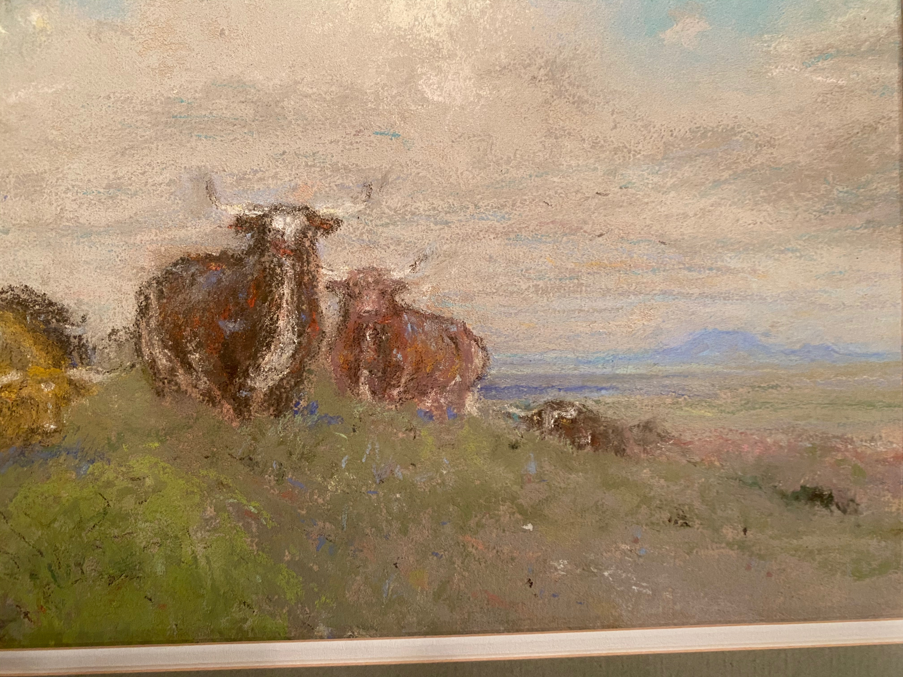

BACKGROUND:

In Frank Reaugh’s will dated May 16, 1940, filed before his death, the painter noted, “The main part of my property is in pictures… These are largely of the great prairies of Texas and the longhorned cattle of fifty years ago . . . It is my wish that these pictures be kept together if only for historical reasons. They create the spirit of the time. They show the sky unsullied by smoke, and the broad opalescent prairies not disfigured by wire fences or other signs of man."
Reaugh died in poverty in Dallas in 1945 at the age of eighty-four.
Today, Reaugh is not even a token presence in most Texas museums. The only true public display of his art is at the Panhandle-Plains Historical Museum, in Canyon, Texas. The Reaugh estate ended up there by default in 1960 after being ignored and rejected by several more “discriminating” art institutions.
In 1966 the University of Texas agreed to transfer a number of Reaugh artworks with the Panhandle-Plains Historical Museum (PPHM) in order to even out Reaugh’s more significant paintings and pastel studies held in the collections at the University of Texas and the Panhandle-Plains Historical Museum.
In 2015, the Harry Ranson Center in Austin, Texas, staged the retrospective exhibit "Frank Reaugh: Landscapes of Texas and the American West" and published the book “Windows on the West: The Art of Frank Reaugh”. This exhibition, arguably the most comprehensive Reaugh exhibition in history, was curated by Peter Mears, who also authored the above book that served as the exhibition catalog.

PROVENANCE:

The documents and documentation that follows in this paper establishes the provenance of this Frank Reaugh pastel, field study as follows:

1. The painting is created by Frank Reaugh and remains in his possession as part of his personal collection until his death.

2. The painting becomes part of the Frank Reaugh Estate at the time of Frank Reaughs death in 1945.

3. The painting along with the rest of the Frank Reaugh Estate becomes the property of the Panhandle-Plains Historical Museum in 1959/1960.

4. On June 3, 2013 the painting is transferred to Larry, Boettigheimer, Frontiers Texas Gallery, Arlington, Texas by the Panhandle-Plains Historical Museum as part of a trade of four Frank Reaugh pastels for materials on Taos artist W. Herbert Dunton.

5. The painting is sold by Larry Boettigheimer to Sam and Karen Pemberton on June 13, 2013.

6. The painting is included in the 2015 retrospective exhibit "Frank Reaugh: Landscapes of Texas and the American West" at the Ransom Center, Austin, Texas.

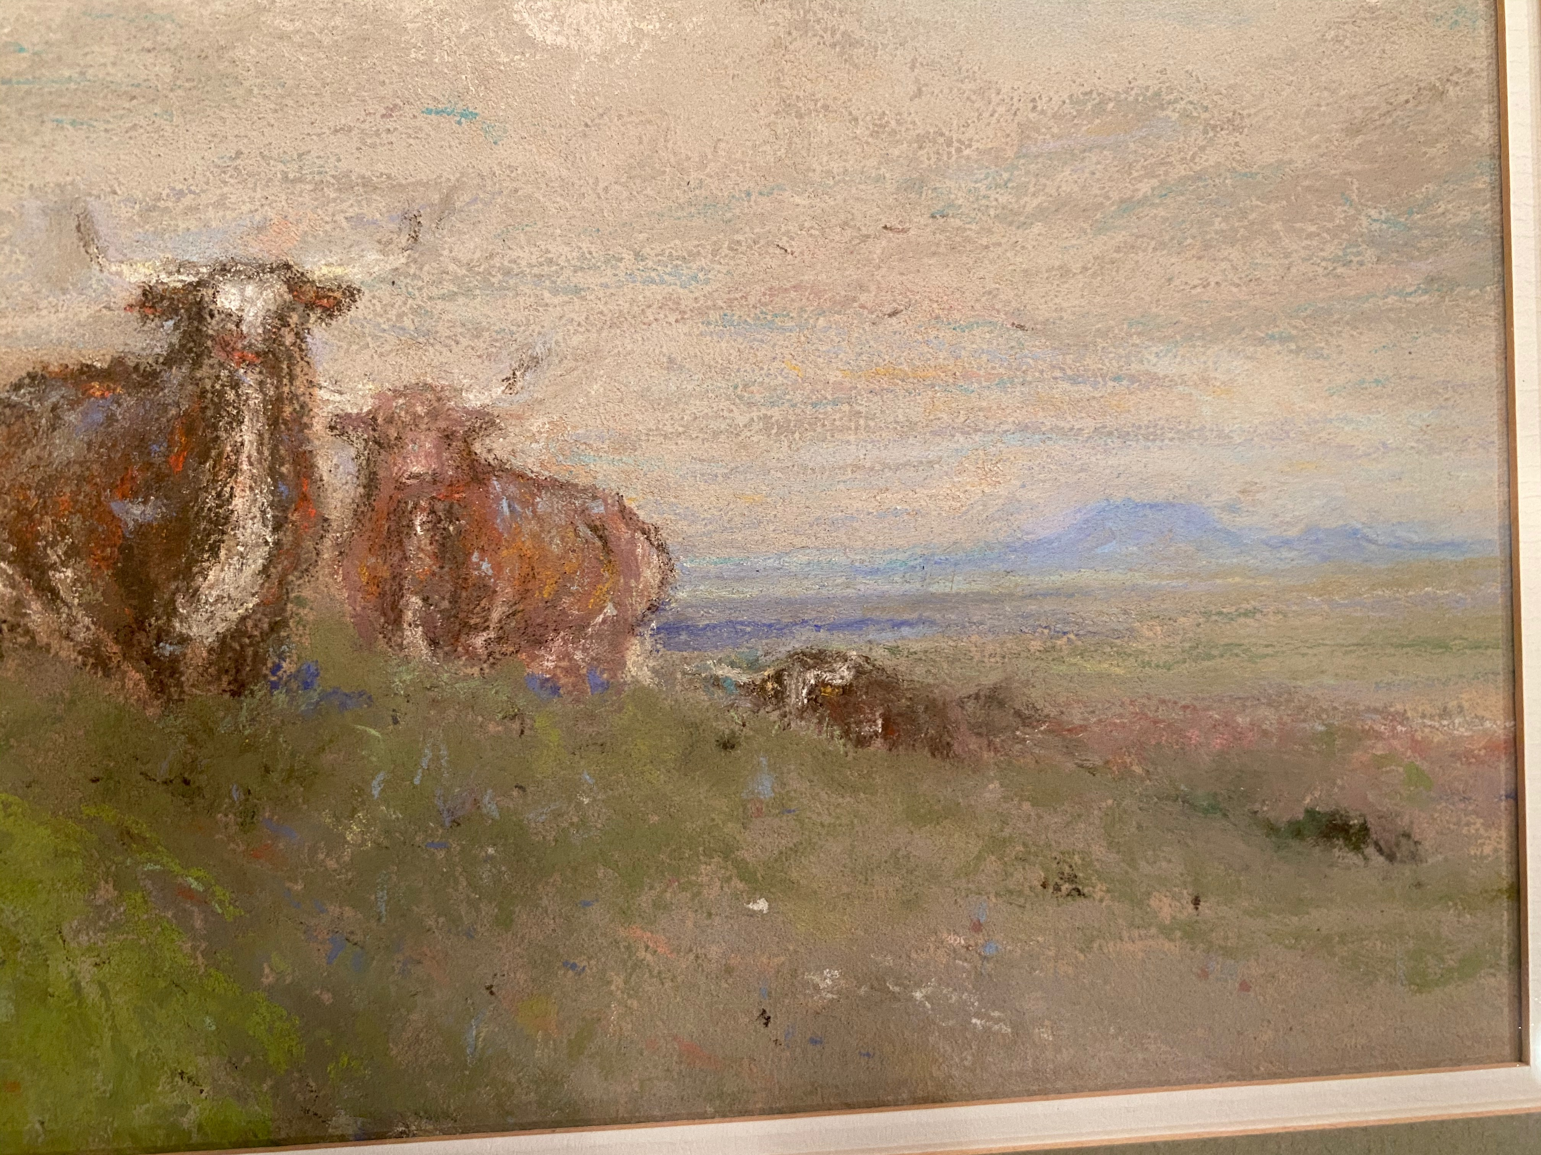

DISCUSSION:

Michael Grauer is the acknowledged expert on Frank Reaugh and his work. He is the author of the most complete work on

Frank Reaugh, “Rounded Up In Glory, Frank Reaugh, Texas Renaissance Man”. This pastel is unsigned, but documentation from Michael Grauer and the PPHM establishes without a doubt that it is an authentic Frank Reaugh pastel.

According to Grauer, who was a curator at PPHM, this pastel was part of the Frank Reaugh estate that was given to the PPHM. It than was in the PPHM collection until the trade with Larry Bottigheimer. The PPHM museum number that was on the back of the original PPHM museum frame was 1865/149.

This pastel was included in the Frank Reaugh movie “Pastel Poet of The Texas Plains”. It was also exhibited as part of the University of Texas exhibition at the Ransom Center, “Frank Reaugh: Landscapes Of Texas And The American West” August 4, 2015 to November 29, 2015. Sam and Karen Pemberton are listed in the book from the exhibition as having loaned this work to the exhibition.

Attached as part of this paper is a trove of documents that outline and document the journey of this painting from the artist and his estate to the PPHM, to Larry Bottigheimer, to Sam and Karen Pemberton to it’s inclusion in the seminal Frank Reaugh Exhibition. These documents speak for themselves and fully tell the story of this painting from its creation by Frank Reaugh to the present owners.
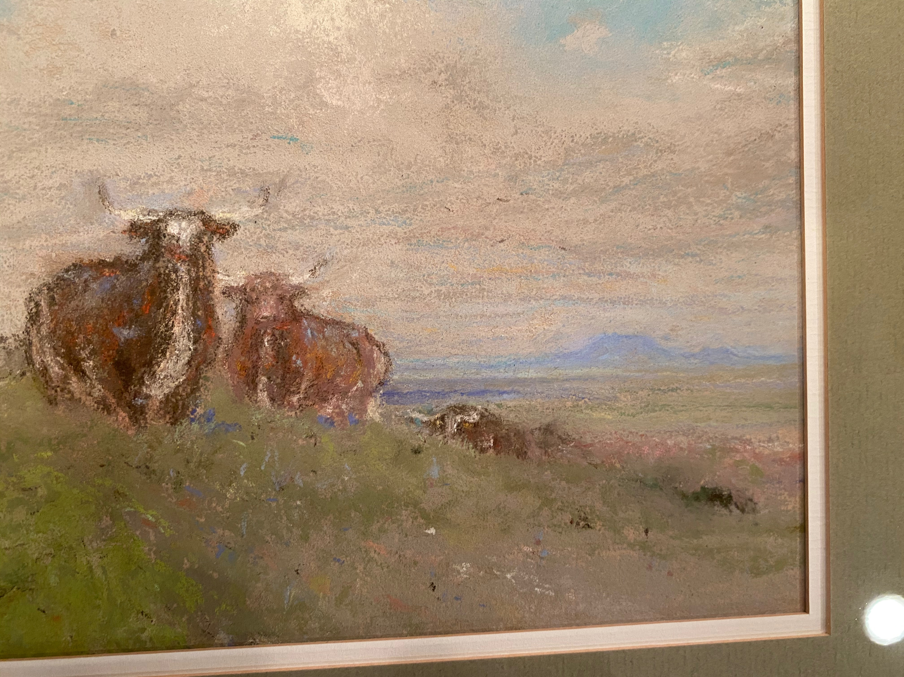

DOCUMENTS:

The documents that follow outline the story of this untitled version of “Approaching Herd/Breezy Morning”, in chronological order.
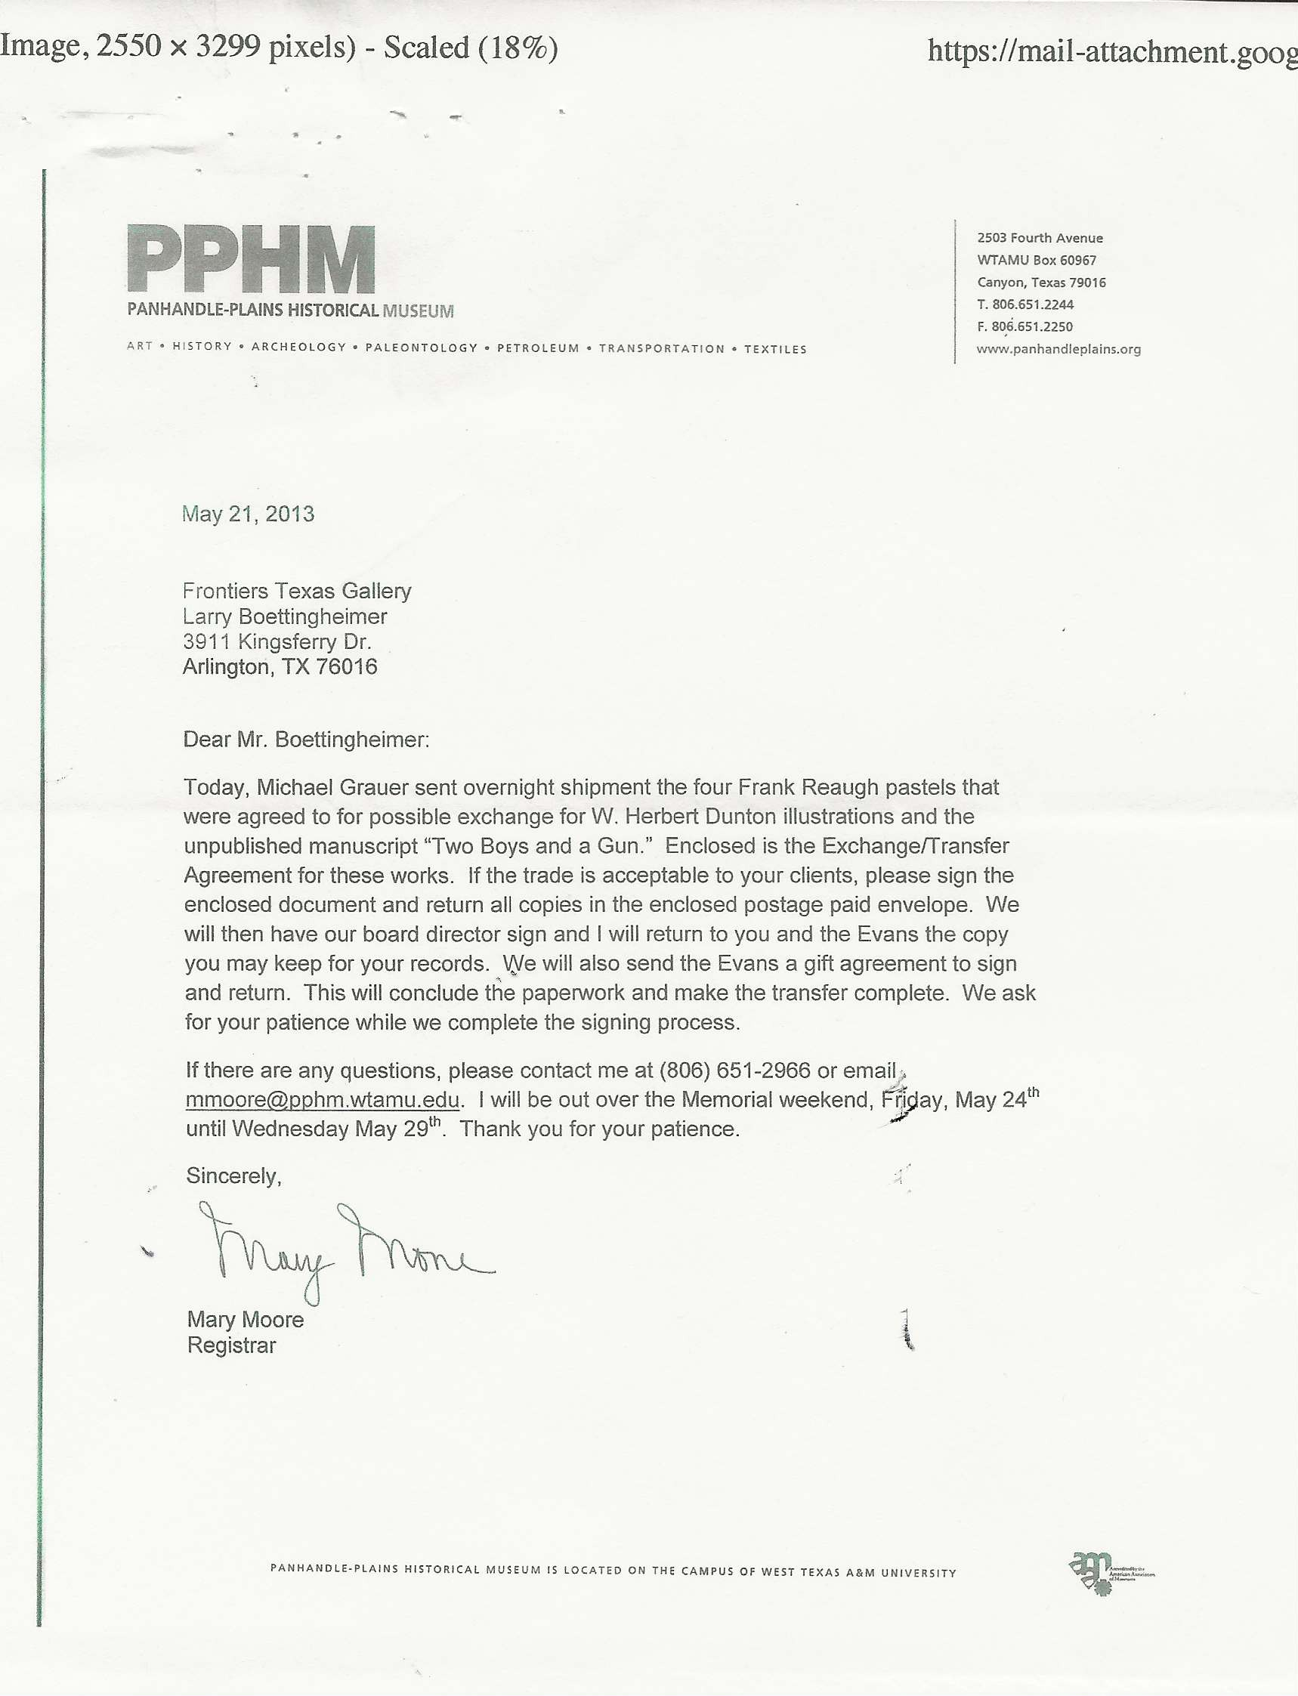

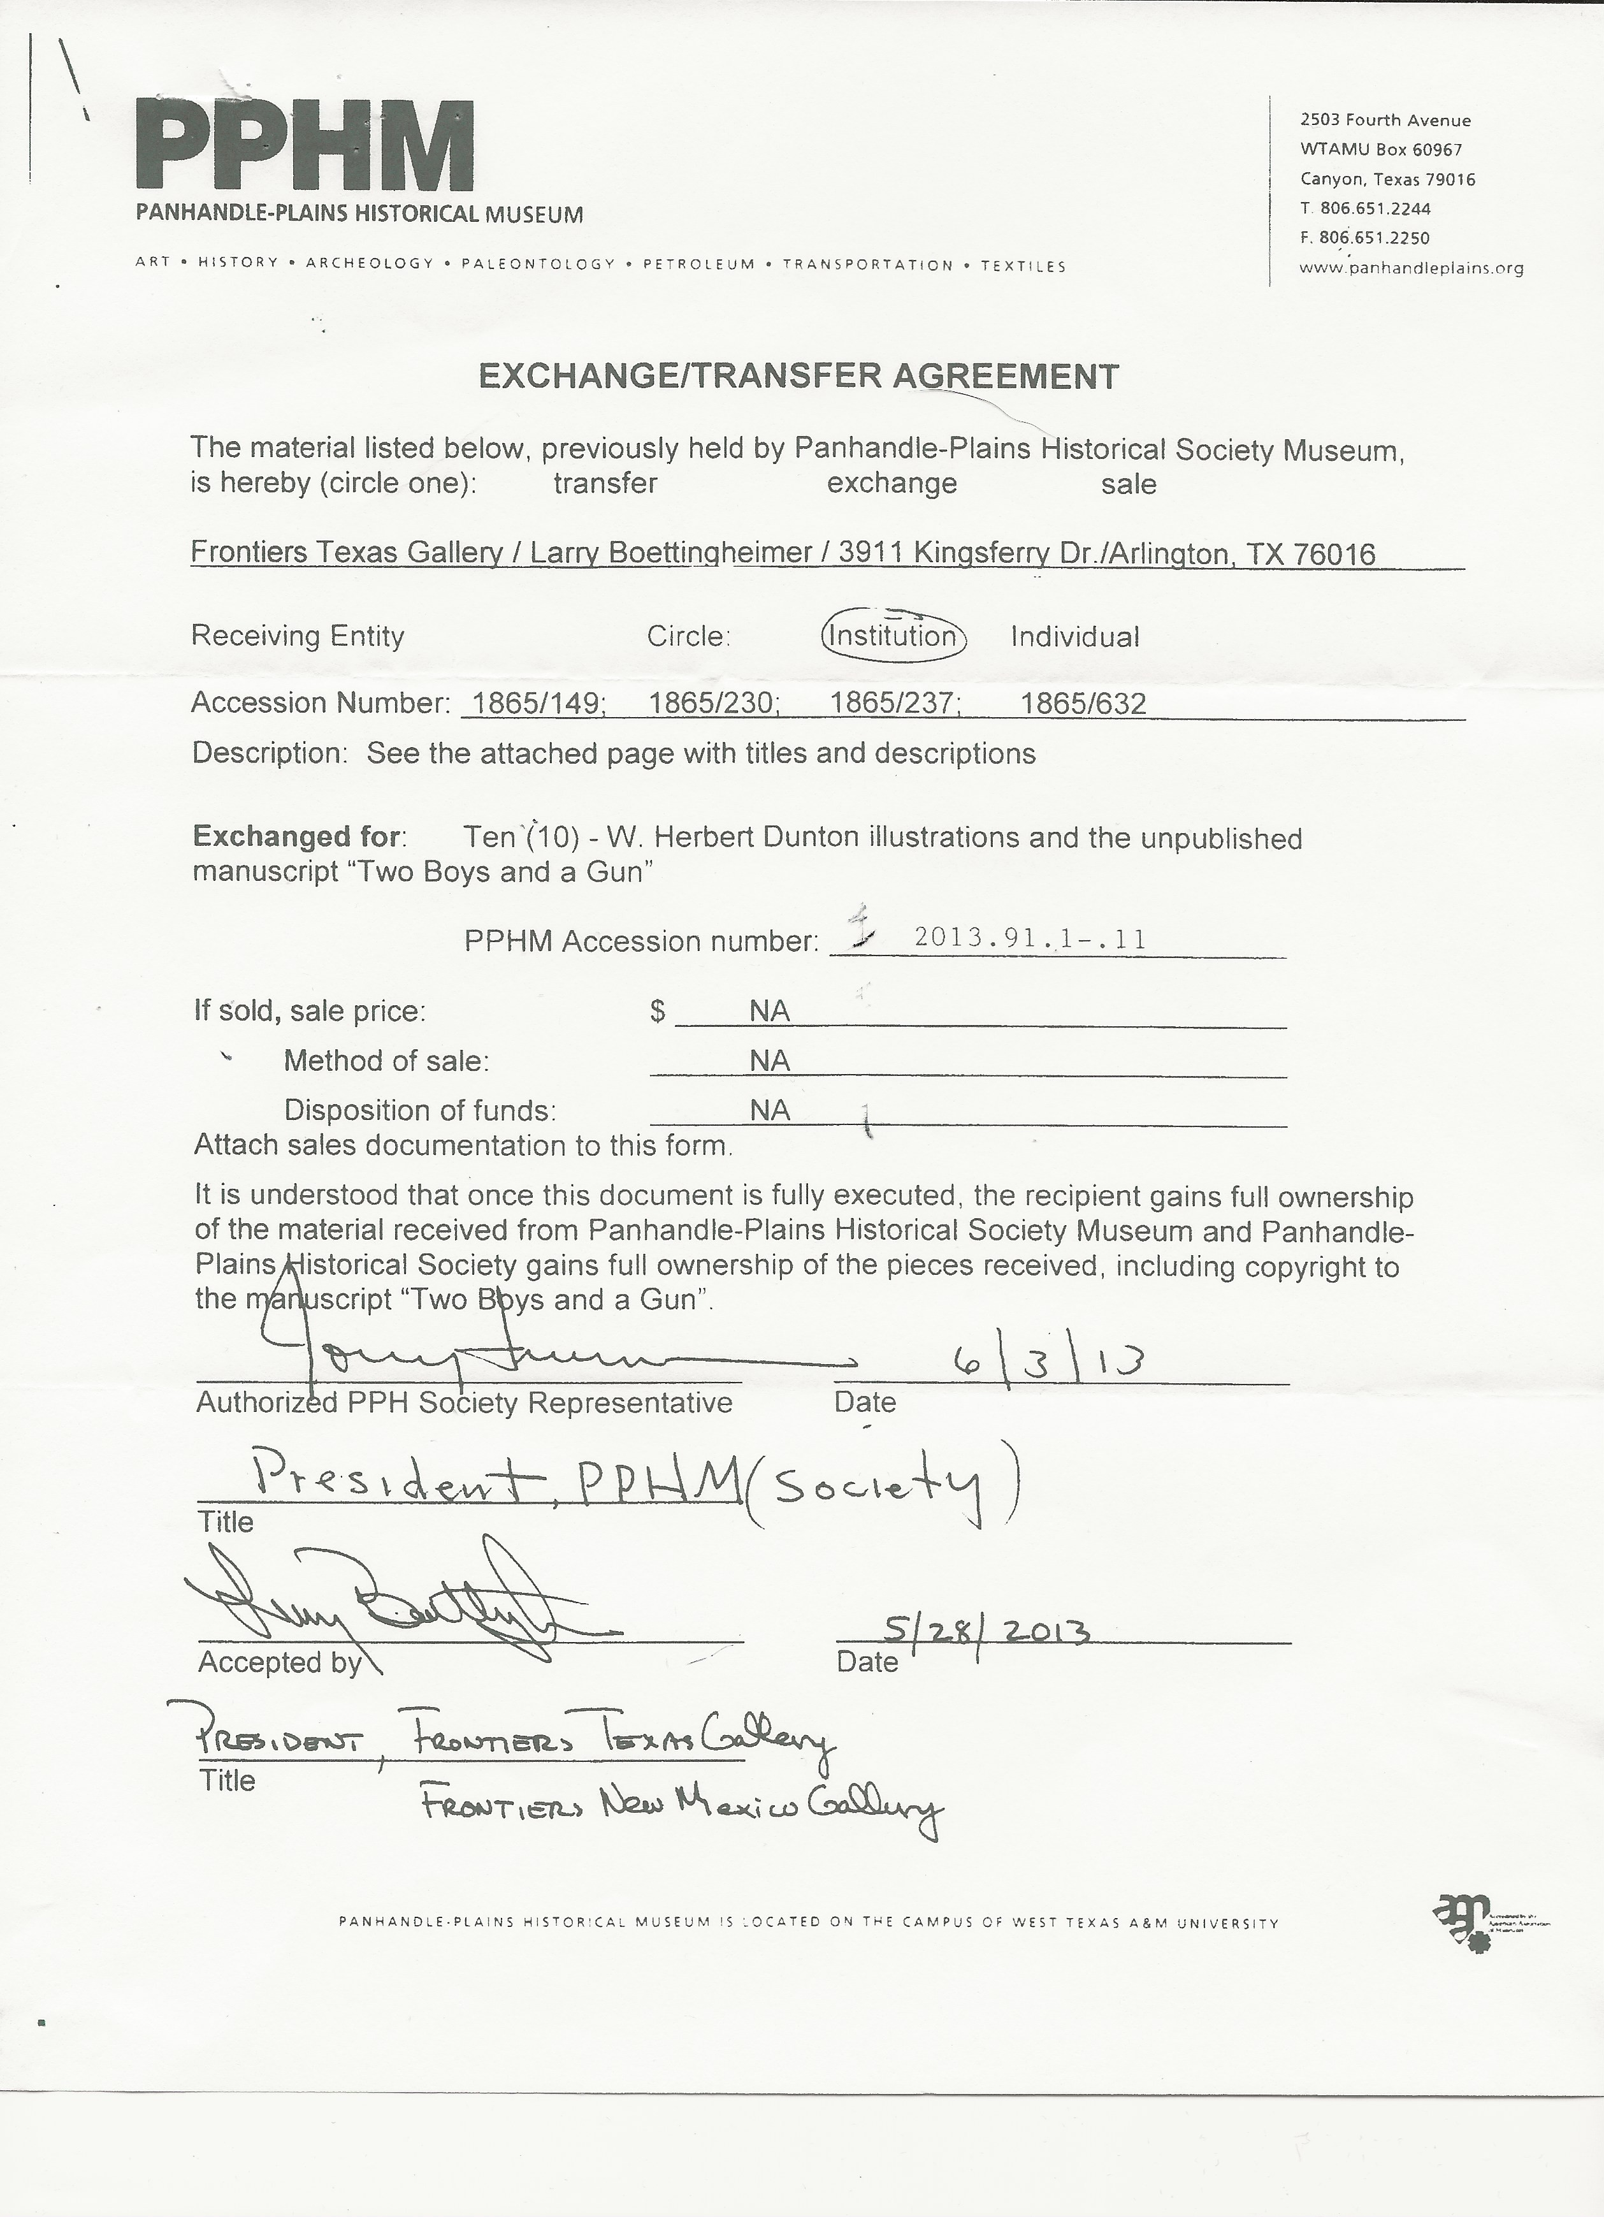

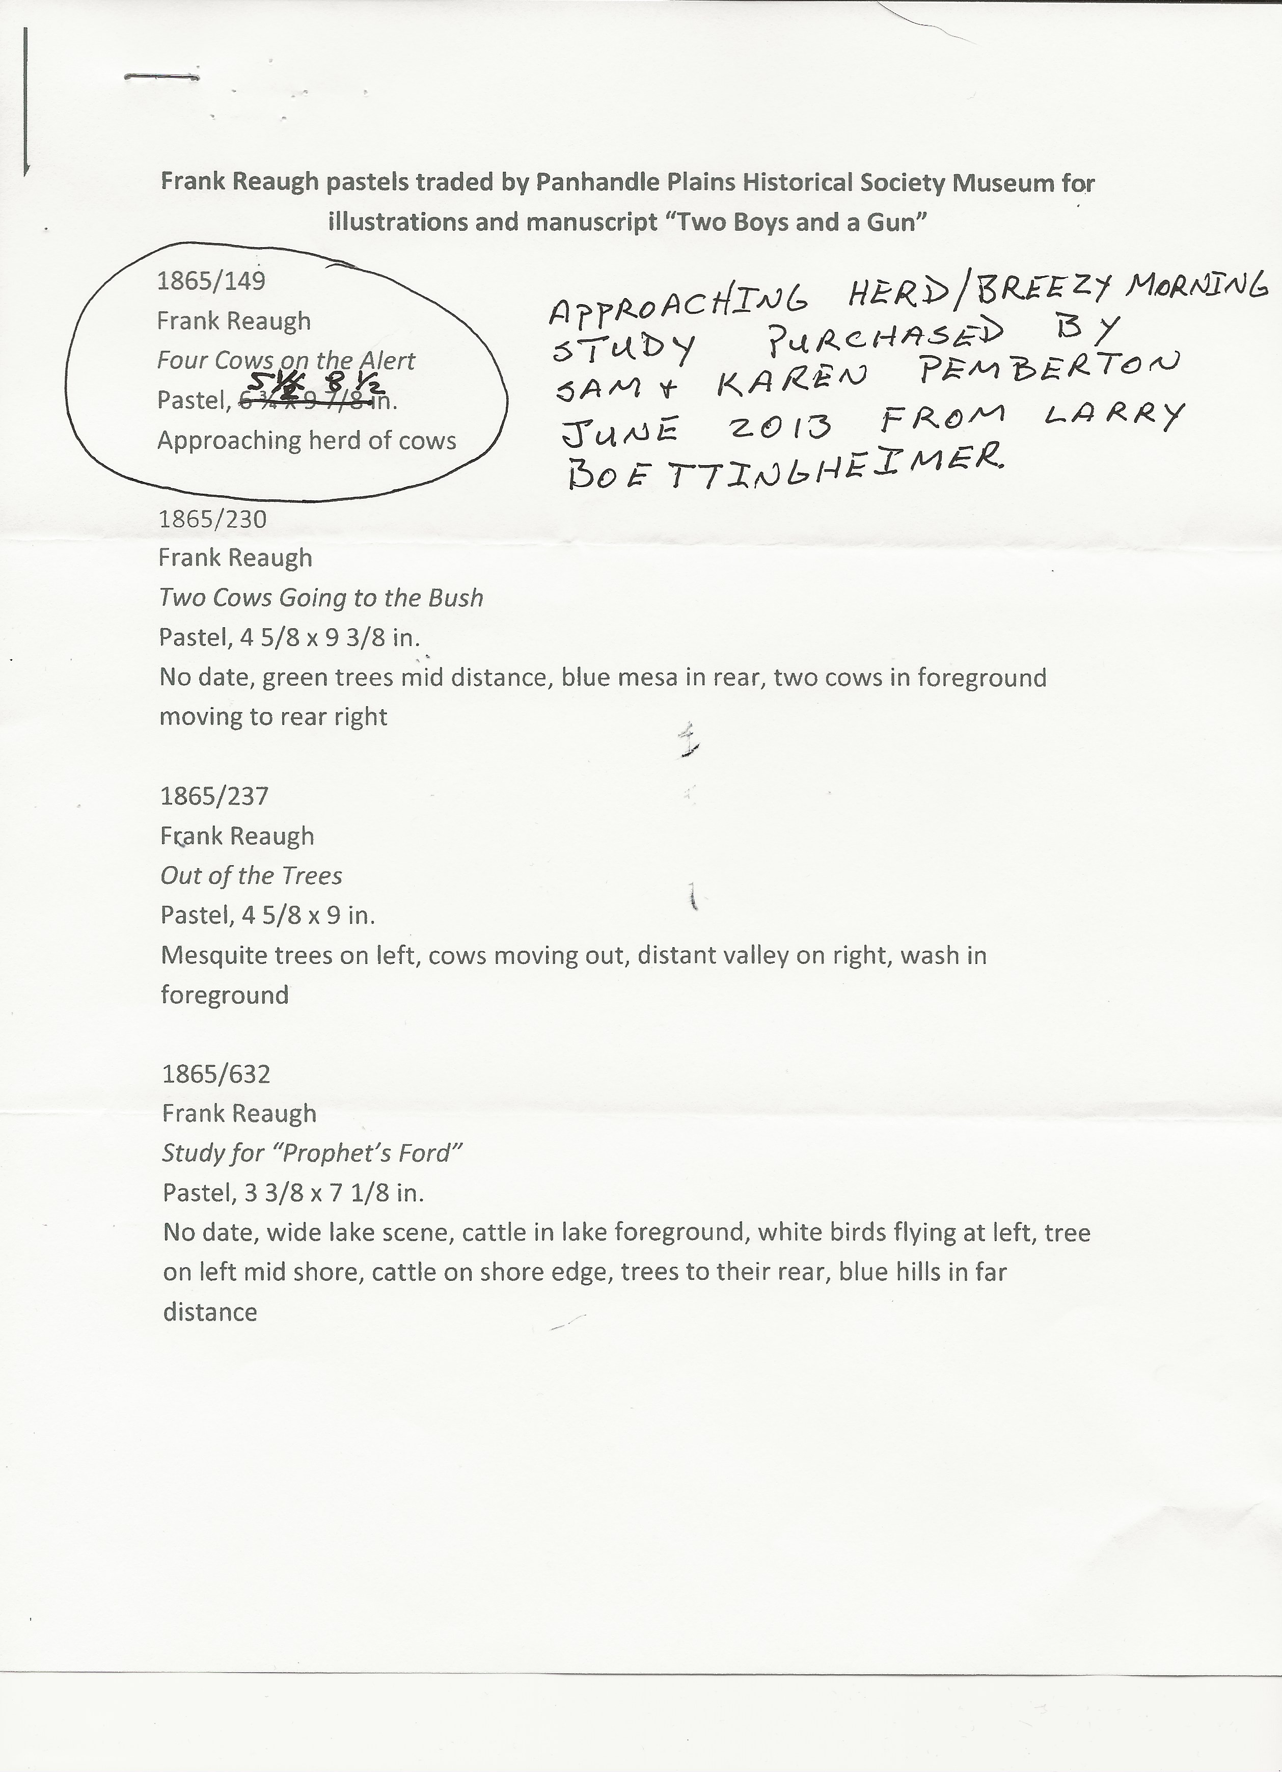

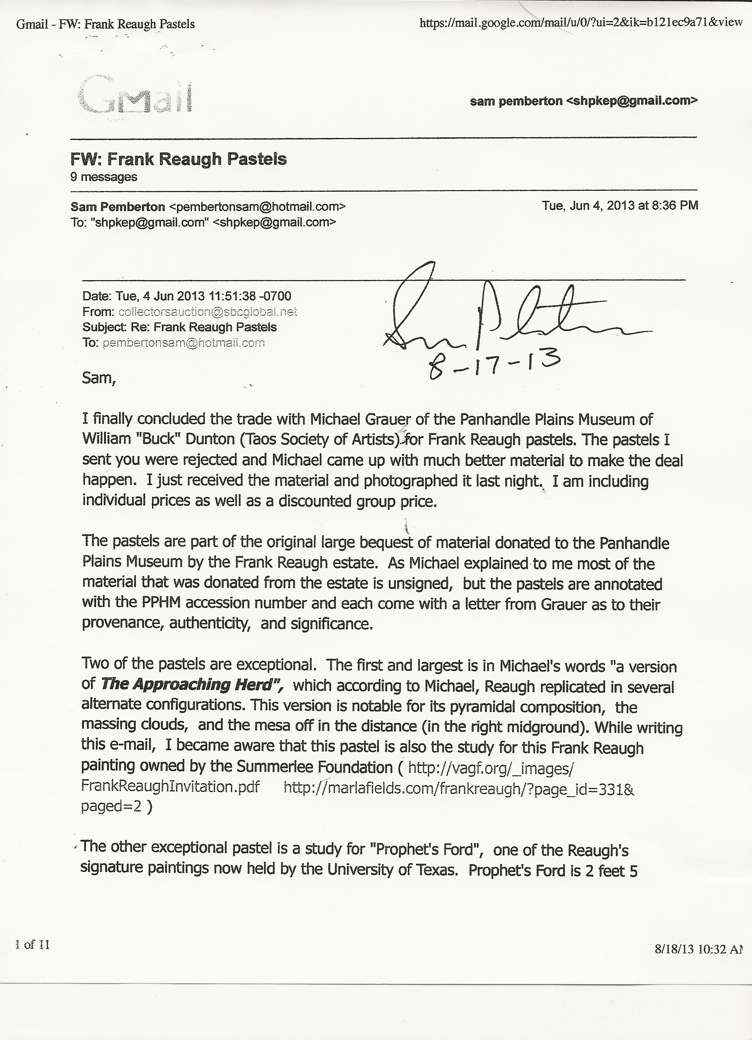

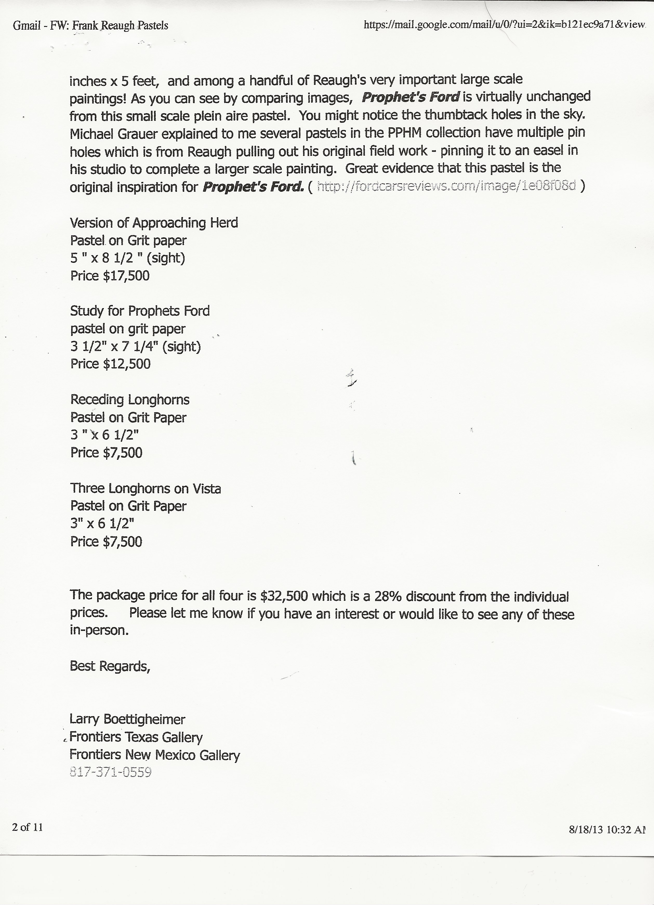

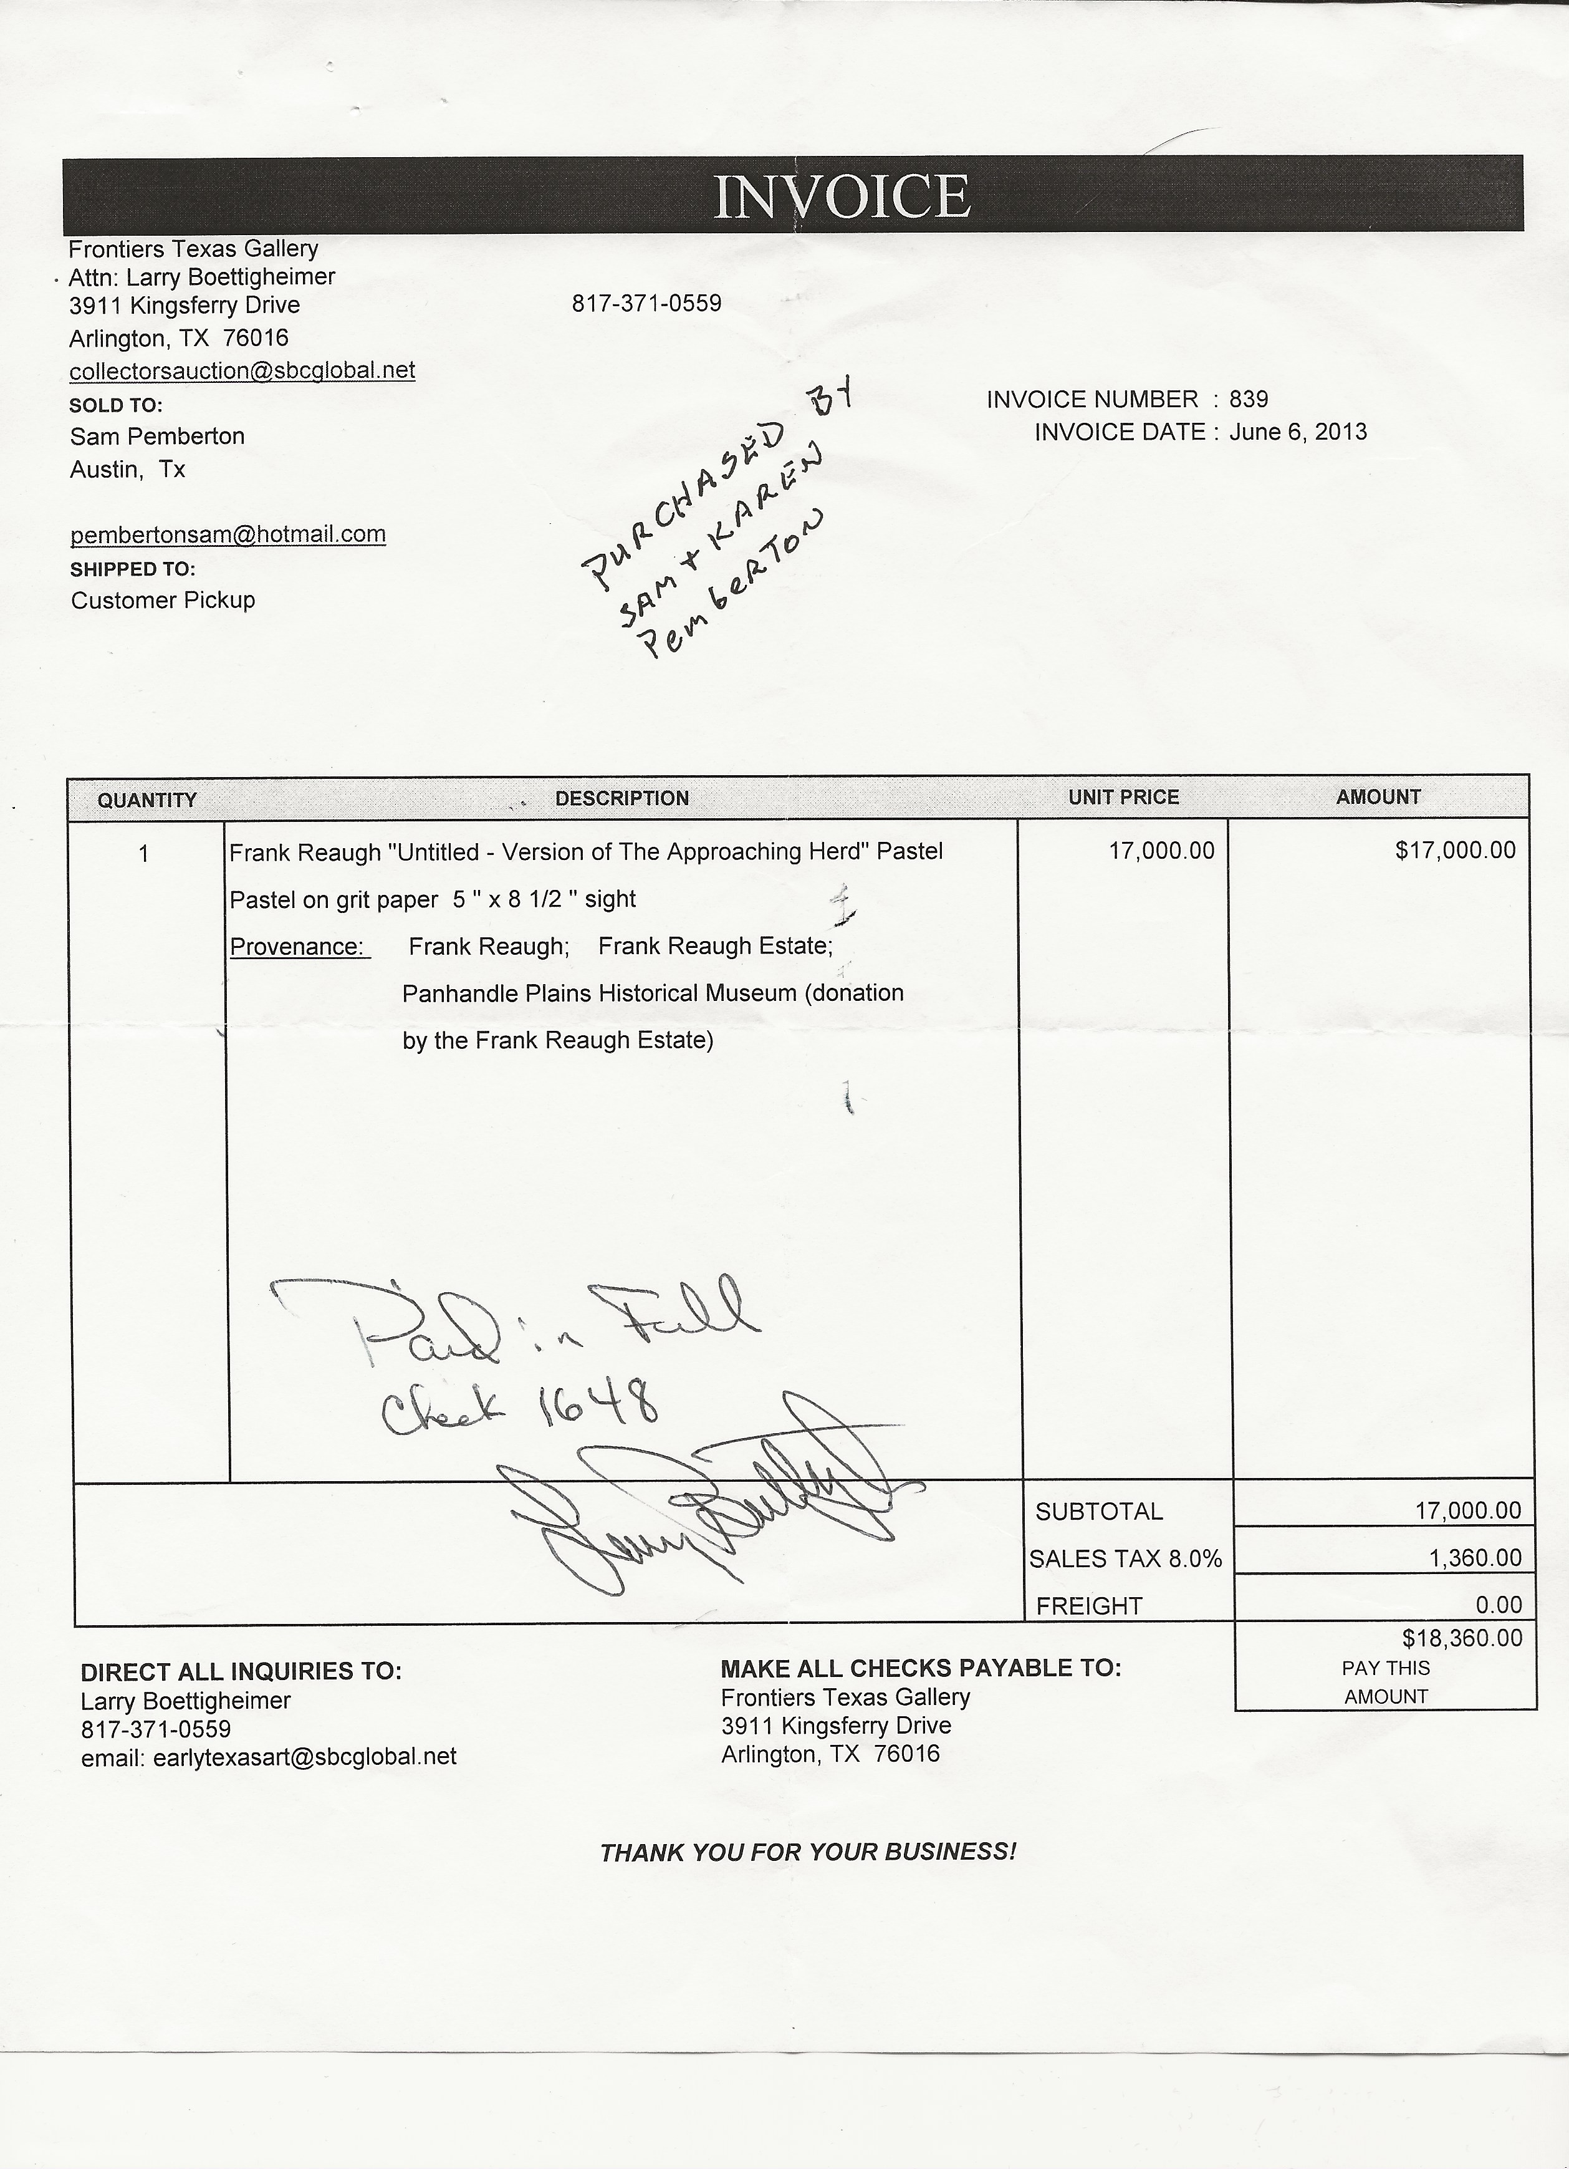

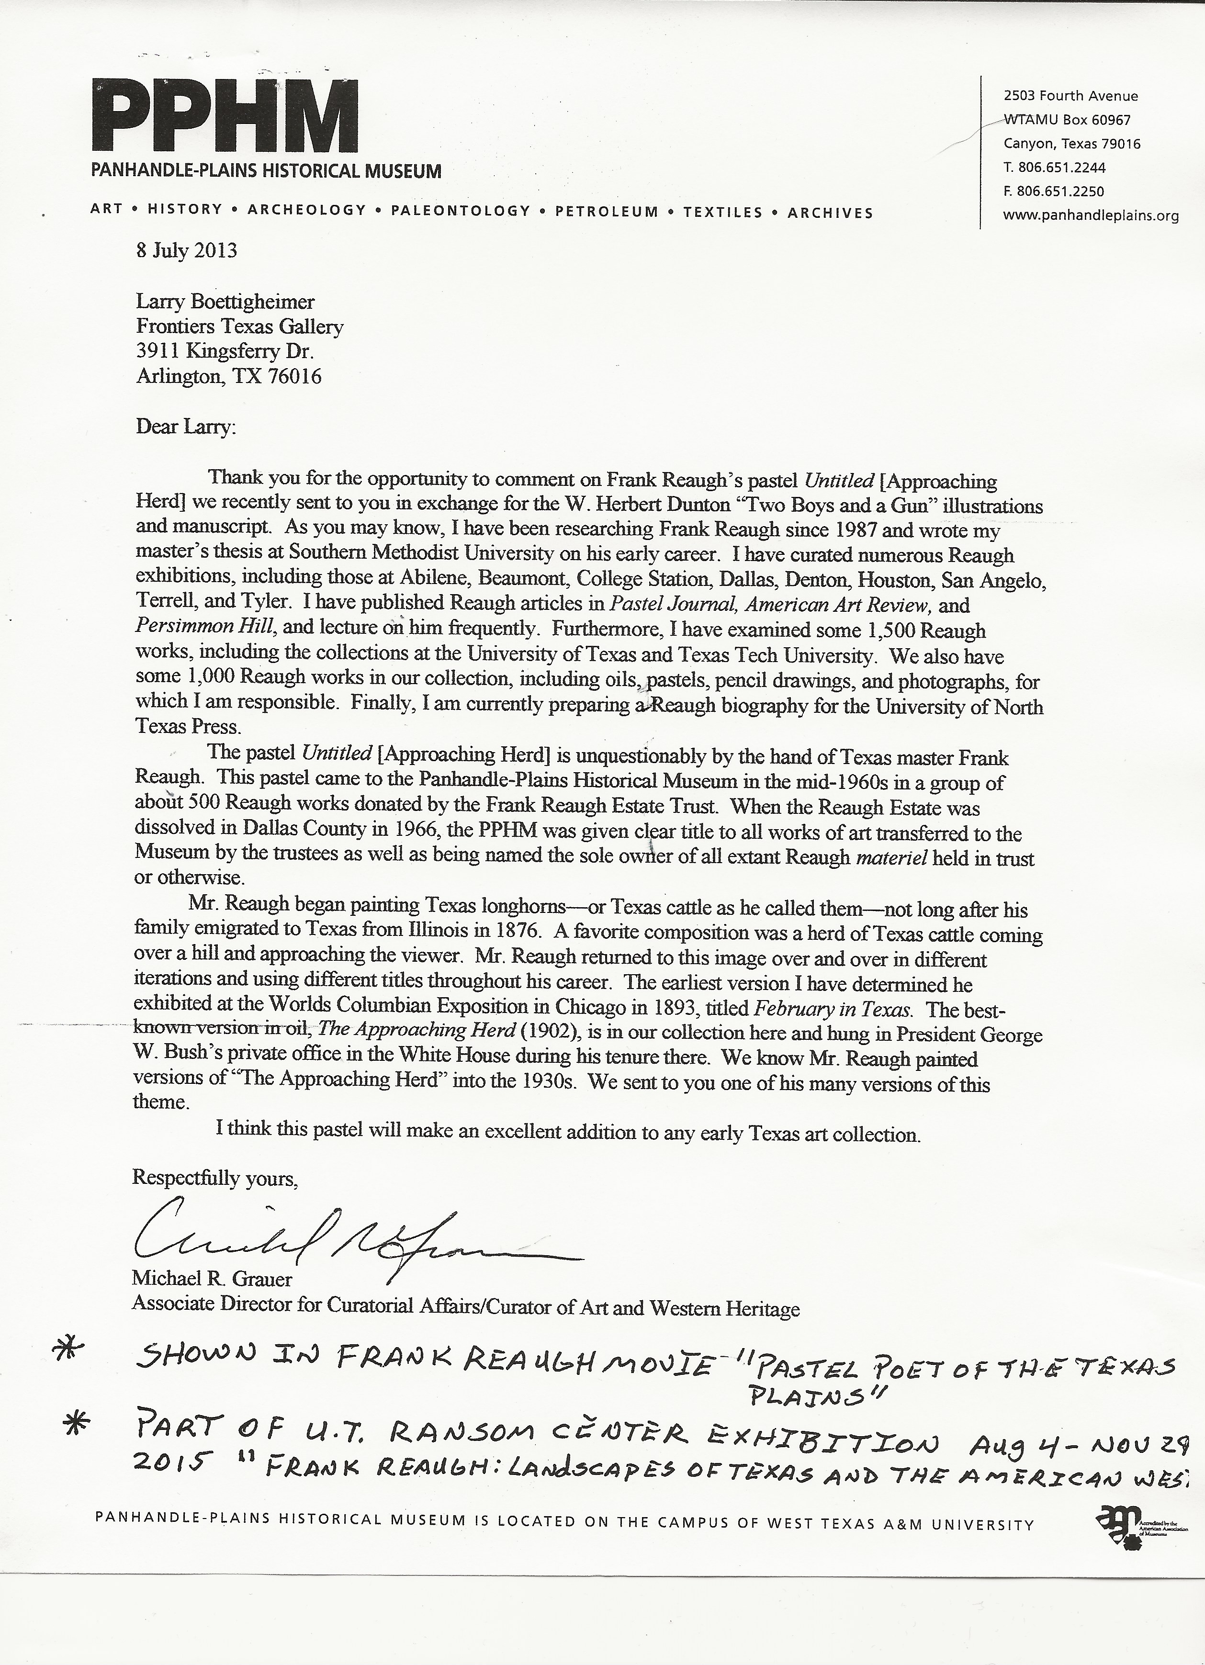

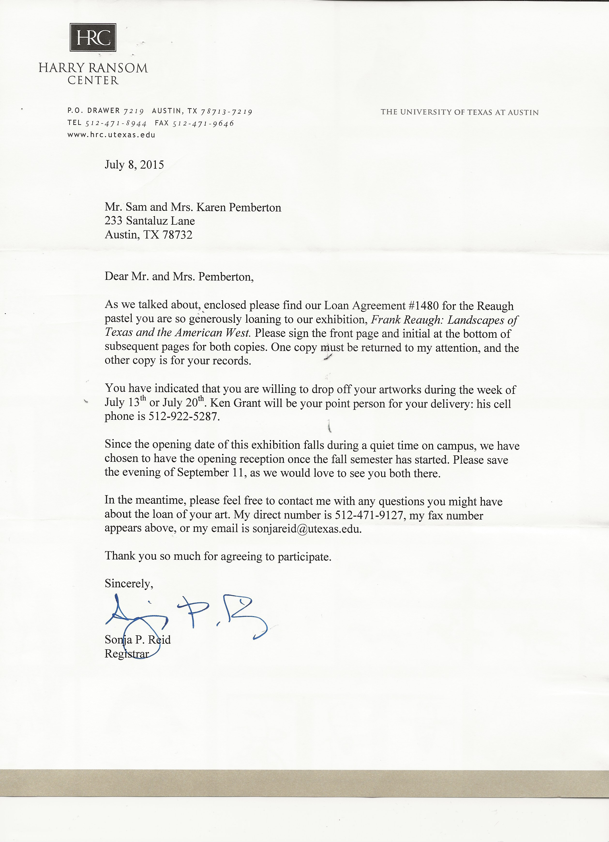

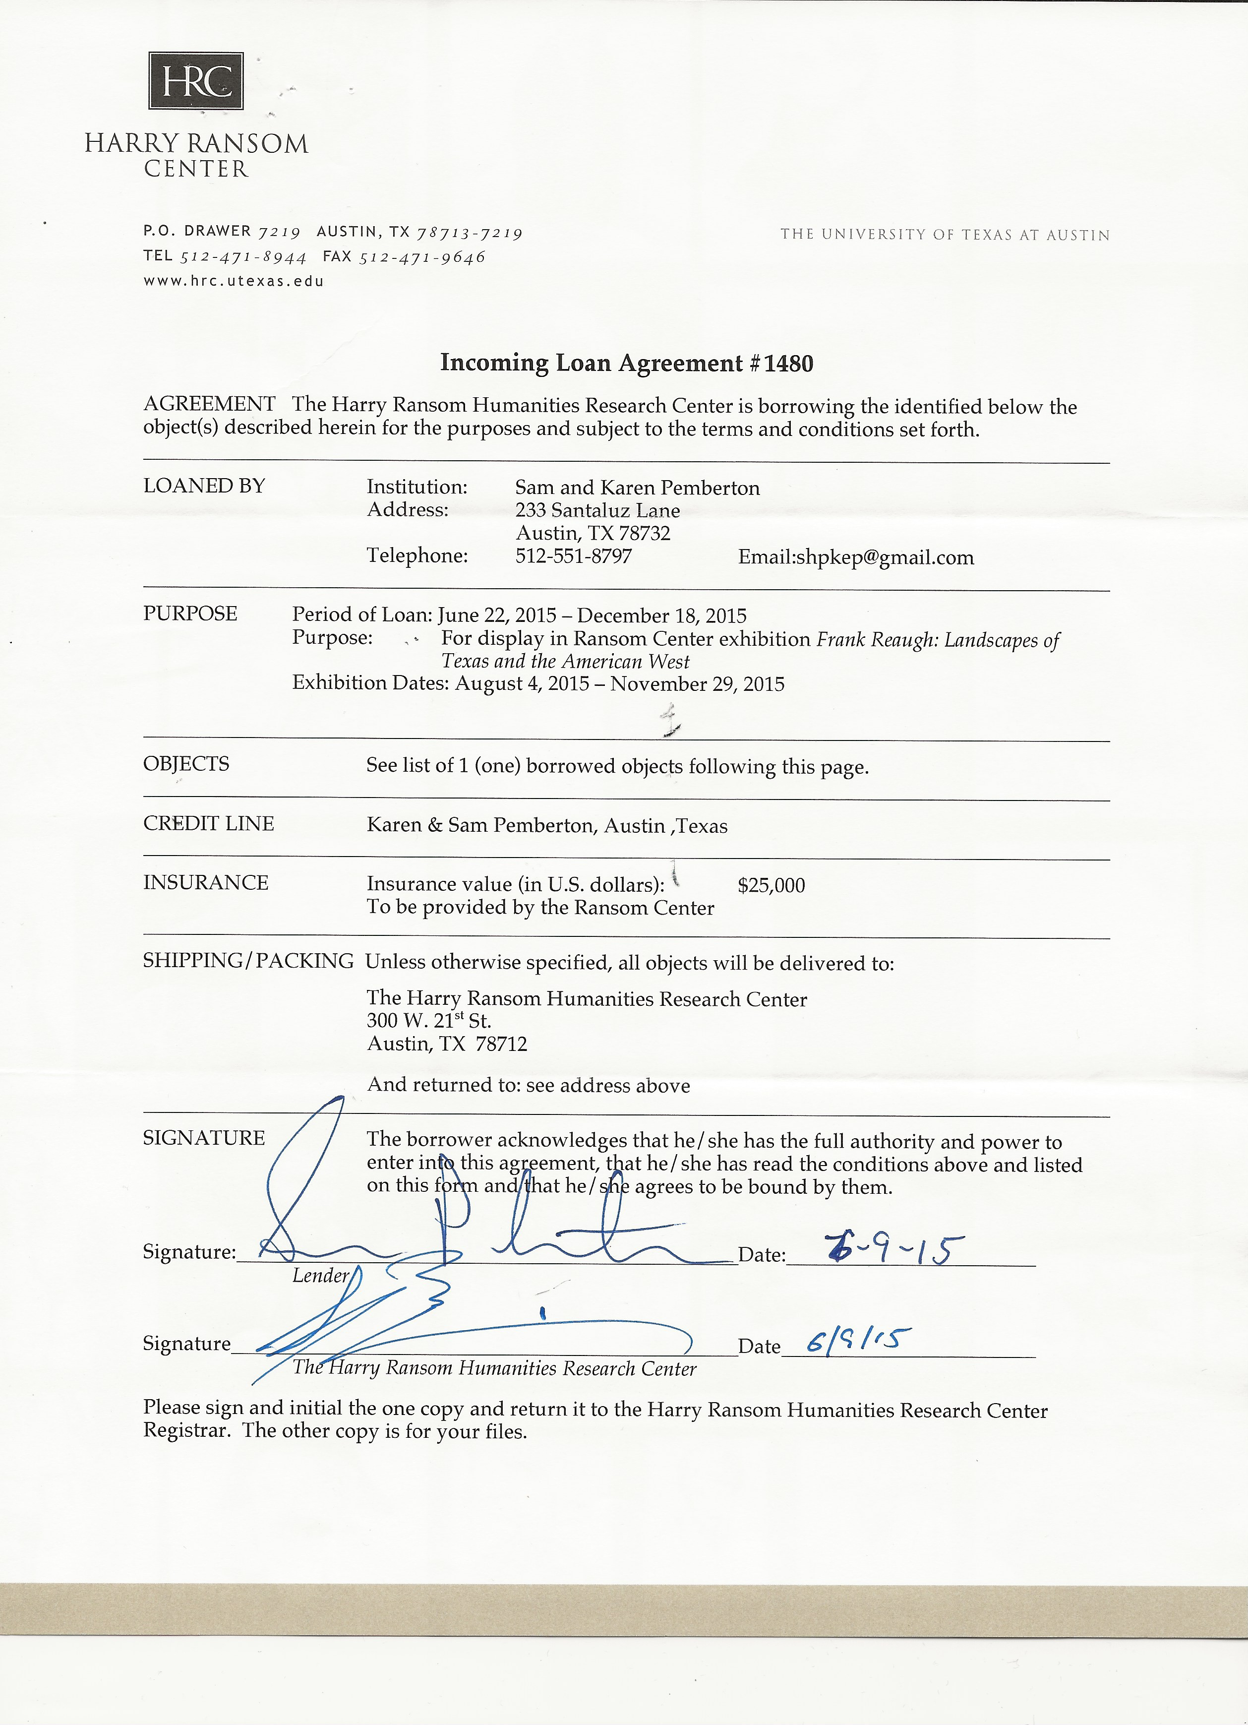

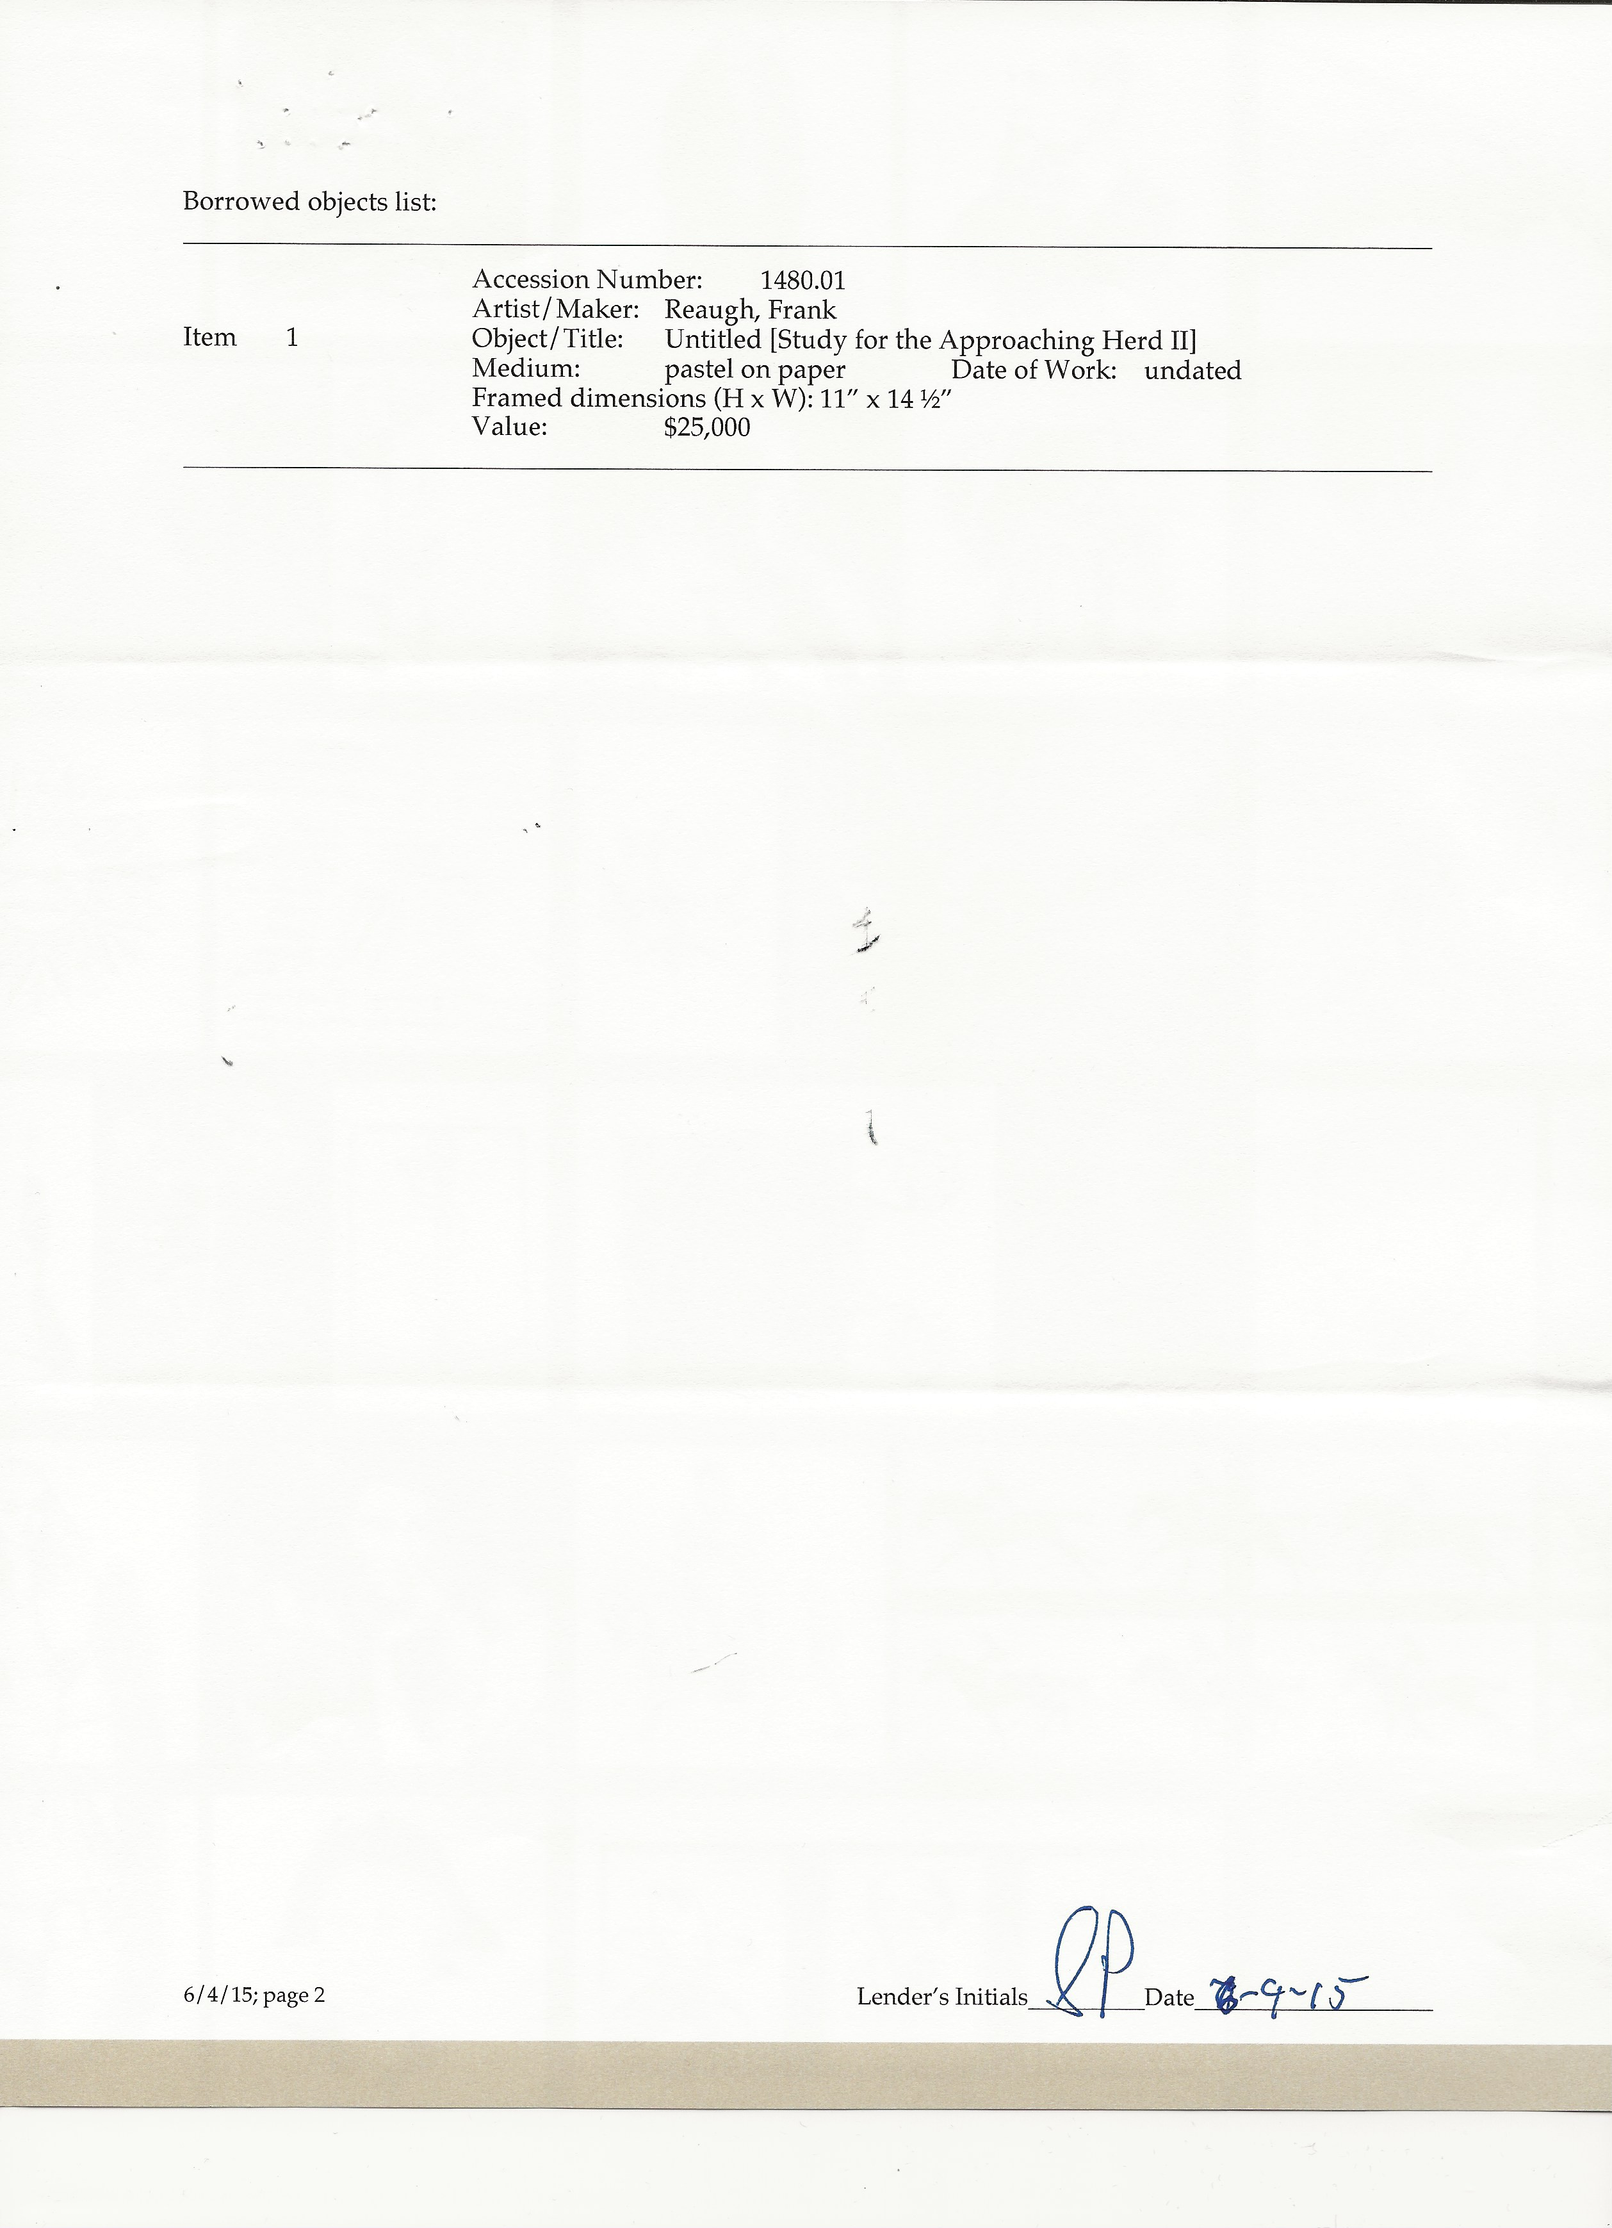

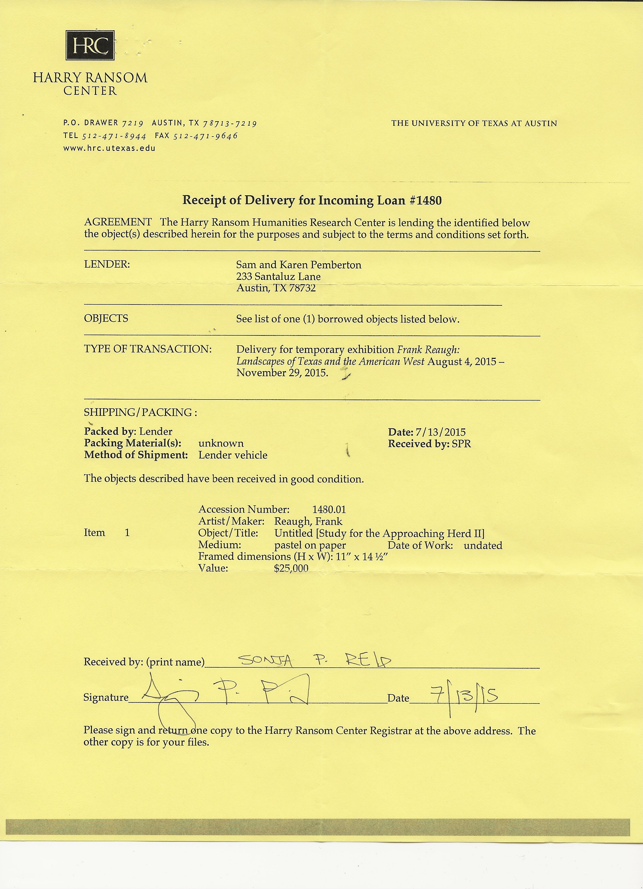

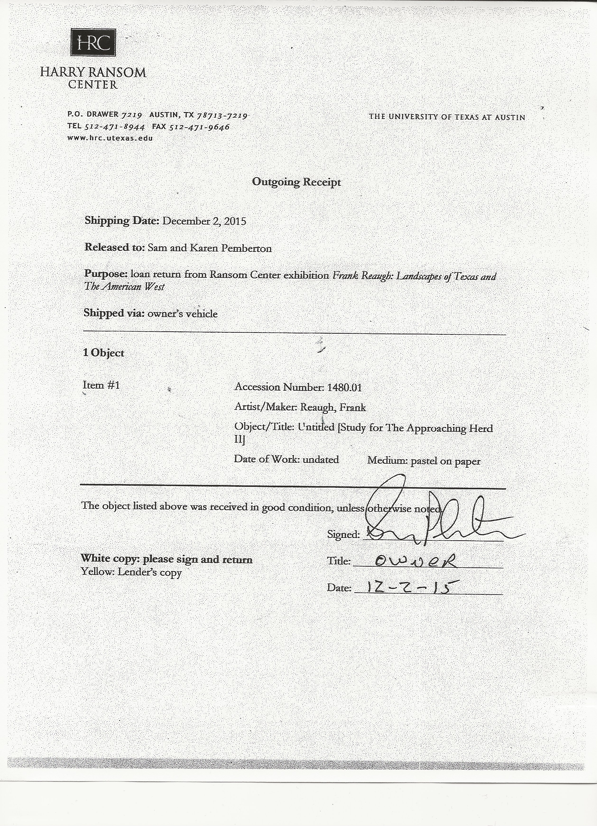

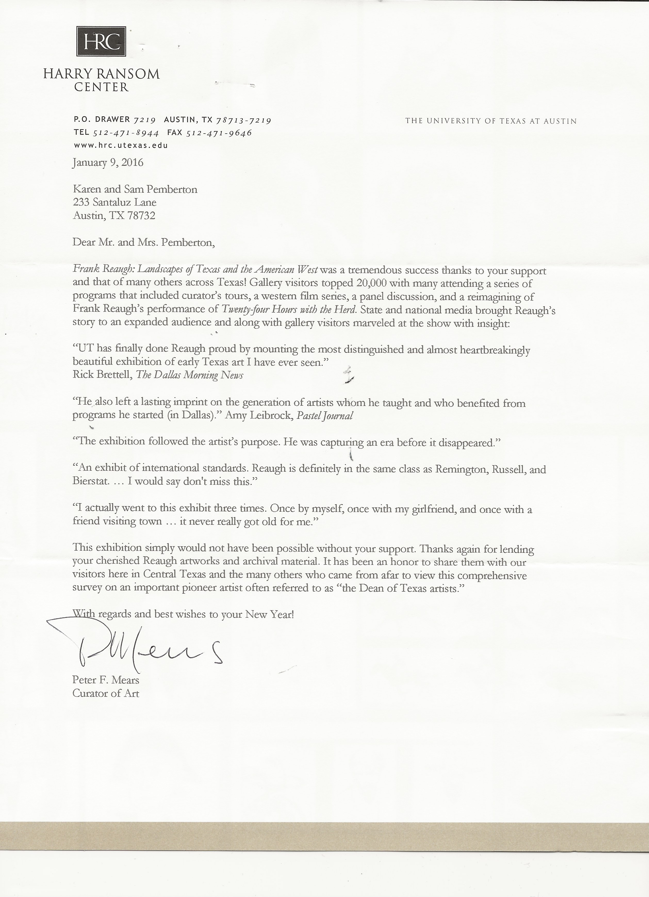

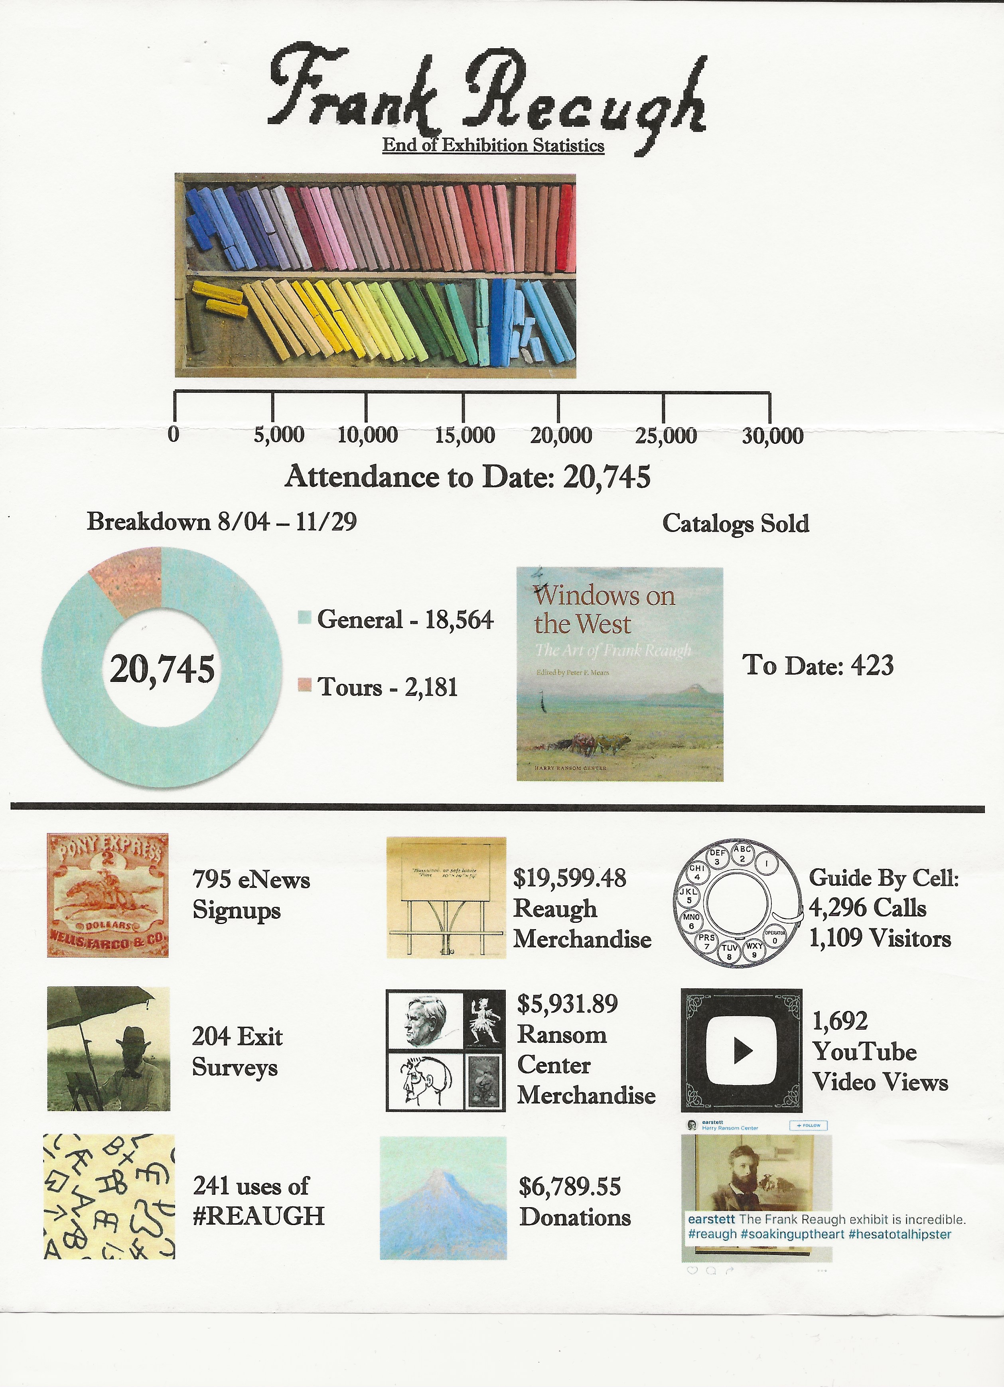

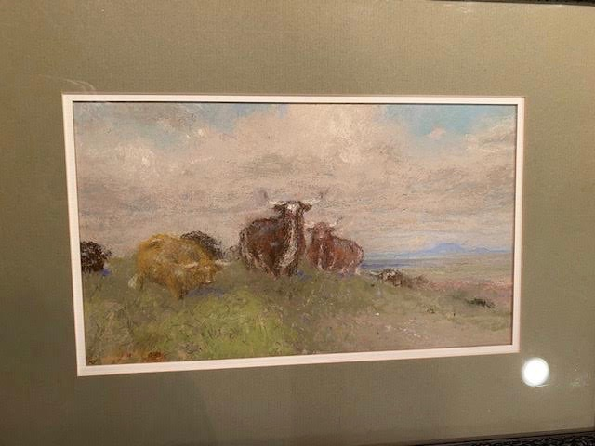

CONCLUSION:

It is my hope that at some time in the far distant future an owner of this painting will discover this paper and these materials and will be amazed to have the provenance information and documents that are here. It is also my hope that CASETA will serve as a repository for these sorts of materials for many decades to come.

Sam Pemberton
281-704-9475
pembertonsam@hotmail.com.
All pages, copyright 2020: Sam Pemberton

